ASSIGNMENT NO.7
Subqueries and Nested Queries

Objective: To understand subqueries in WHERE and SELECT clauses, correlated subqueries, EXISTS, and NOT EXISTS.

Q1) Create a MySQL database named CollegeDB and create two tables: Course and StudentResult.

Column Name | Data Type | Constraint
CourseID | INT | PRIMARY KEY
CourseName | VARCHAR(50) | NOT NULL
Fees | DECIMAL(10,2) | NOT NULL

Column Name | Data Type | Constraint
StudentID | INT | PRIMARY KEY
StudentName | VARCHAR(50) | NOT NULL
CourseID | INT | FOREIGN KEY
City | VARCHAR(30)
Marks | INT

CREATE DATABASE CollegeDB;
USE CollegeDB;

CREATE TABLE Course ( CourseID INT PRIMARY KEY,
CourseName VARCHAR(50) NOT NULL, Fees DECIMAL(10,2) NOT NULL
);

CREATE TABLE StudentResult ( StudentID INT PRIMARY KEY, StudentName VARCHAR(50) NOT NULL, CourseID INT,
City VARCHAR(30),
Marks INT,
FOREIGN KEY (CourseID) REFERENCES Course(CourseID)
);

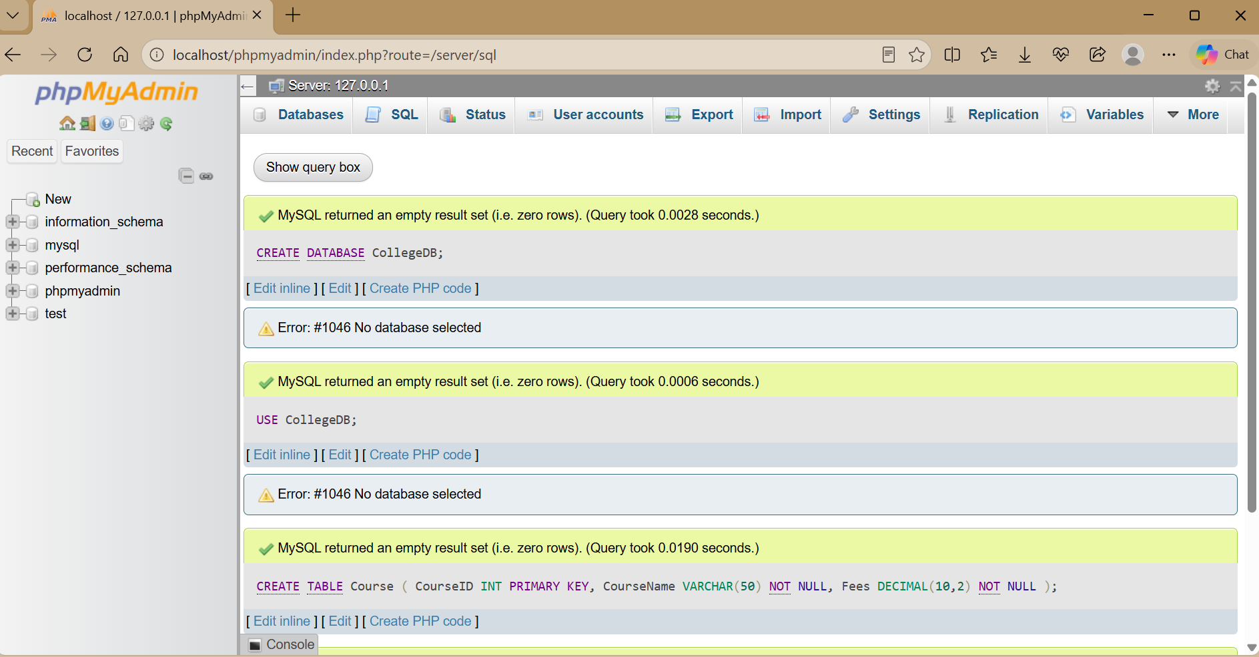

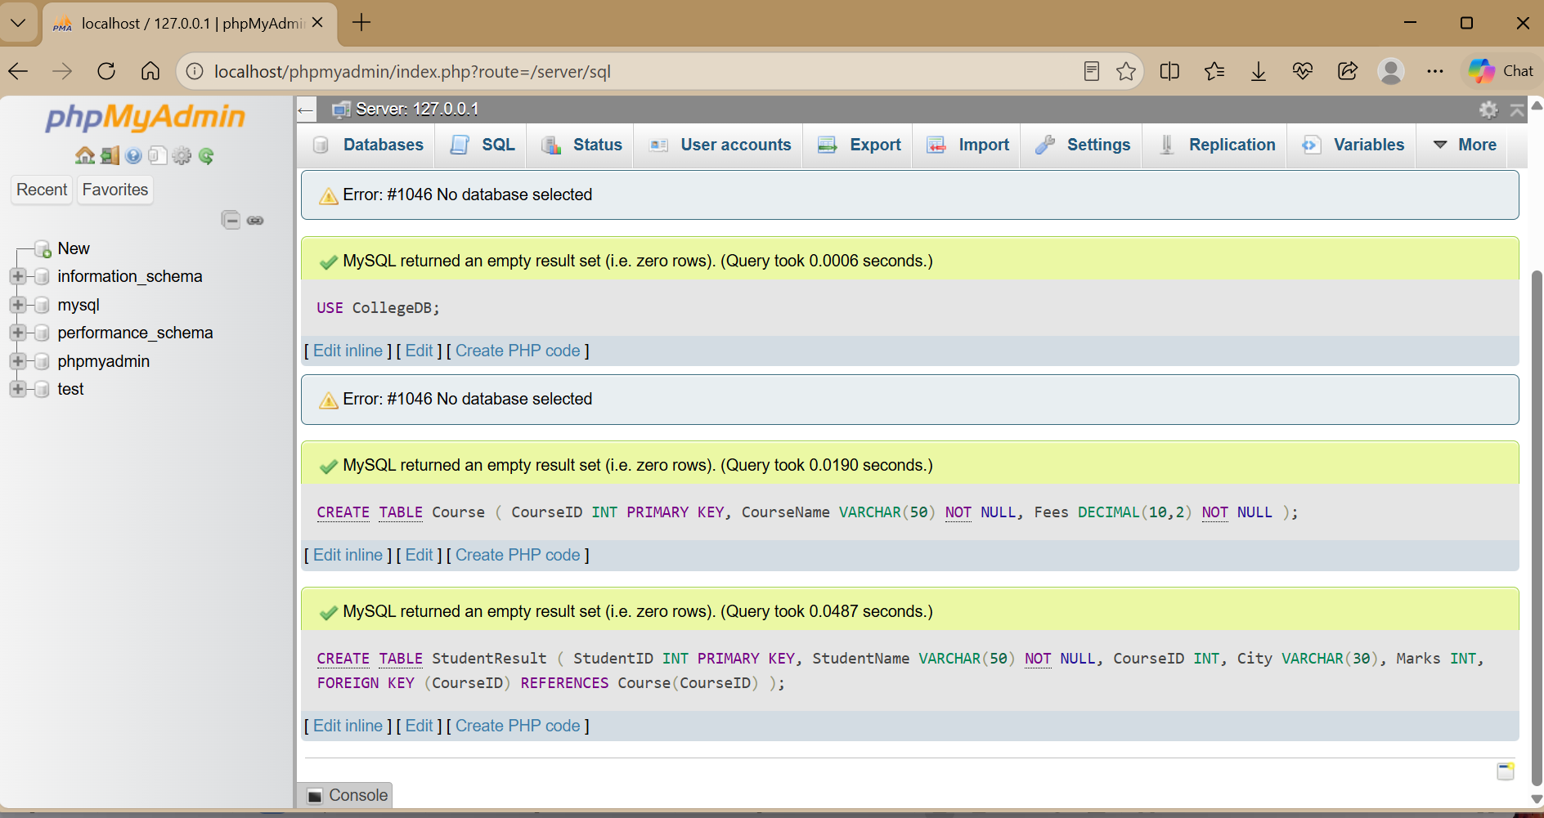

Inserting at least 4 course records and 10 student records.

INSERT INTO Course (CourseID, CourseName, Fees) VALUES
(101, 'BSc IT', 45000.00),
(102, 'BCA', 40000.00),
(103, 'BSc CS', 42000.00),
(104, 'Data Science', 55000.00);

INSERT INTO StudentResult
(StudentID, StudentName, CourseID, City, Marks) VALUES
(1, 'Rahul Sharma', 101, 'Mumbai', 78),
(2, 'Priya Patil', 102, 'Pune', 85),
(3, 'Aman Verma', 103, 'Nashik', 67),
(4, 'Sneha Joshi', 101, 'Mumbai', 91),
(5, 'Karan Mehta', 102, 'Thane', 74),
(6, 'Neha Shah', 101, 'Pune', 88),
(7, 'Rohan Desai', 103, 'Mumbai', 69),
(8, 'Meera Kulkarni', 102, 'Nashik', 82),
(9, 'Arjun Nair', 101, 'Thane', 59),
(10, 'Divya More', 102, 'Mumbai', 93);

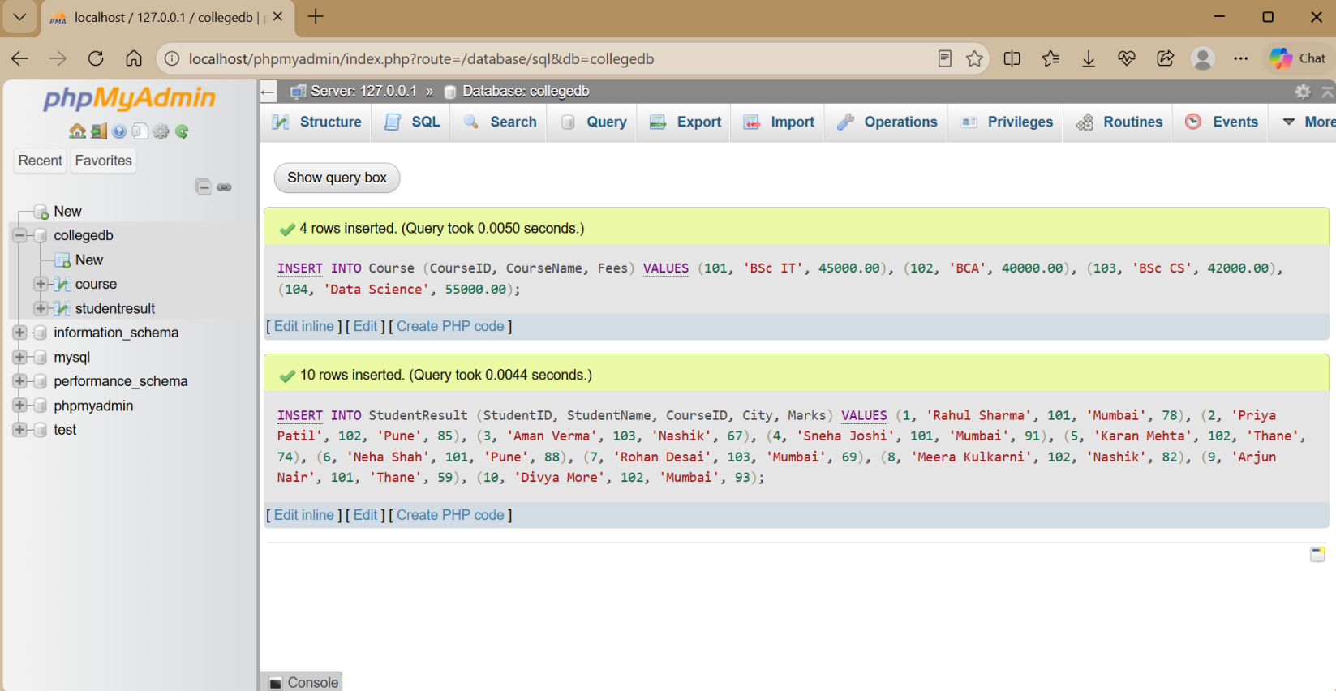

Explanation: Course records are inserted before StudentResult because StudentResult.CourseID is a foreign key referencing Course.CourseID.

Q2) Display students whose marks are greater than the average marks of all students.

SELECT StudentName, Marks
FROM StudentResult
WHERE Marks > (
SELECT AVG(Marks)
FROM StudentResult
);

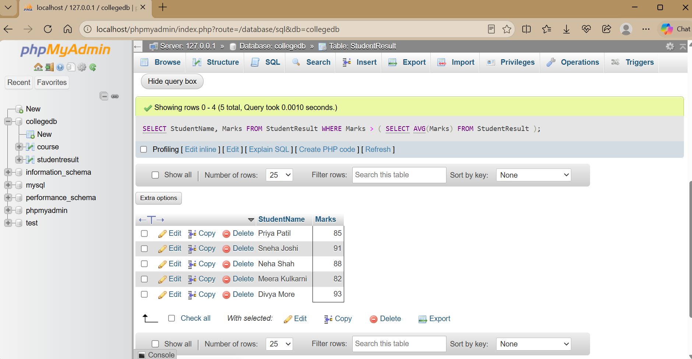

The inner query calculates the overall average. The outer query displays students whose marks are above that average

Q3) Display all students enrolled in the BCA course using a subquery.

SELECT StudentID, StudentName, CourseID, Marks
FROM StudentResult
WHERE CourseID = (
SELECT CourseID
FROM Course
WHERE CourseName = 'BCA'
);

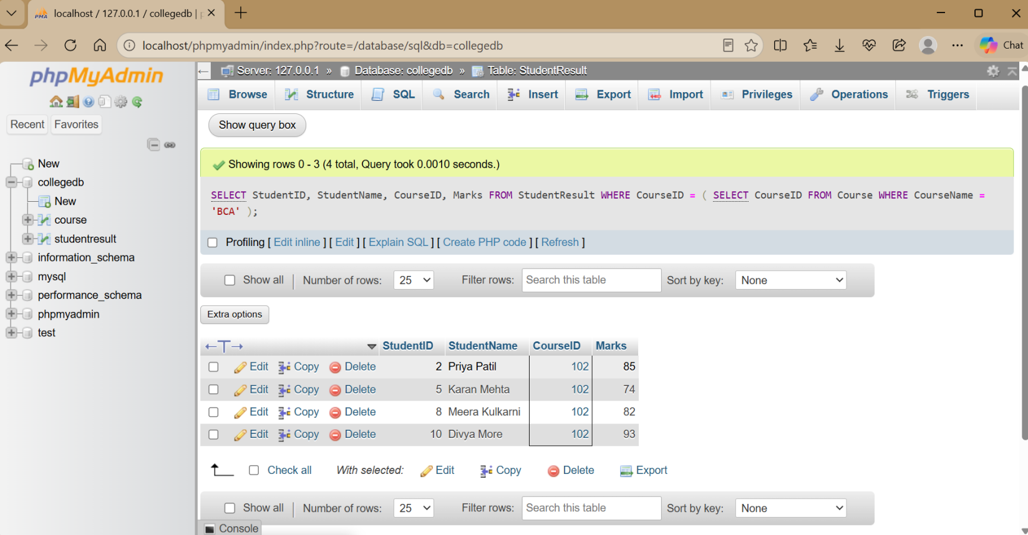

The inner query finds the CourseID of BCA. The outer query uses that CourseID to find the students.

Q4) Display each student with the overall average marks using a subquery in SELECT.

SELECT
StudentName,
Marks,
(SELECT AVG(Marks) FROM StudentResult) AS AverageMarks FROM StudentResult;

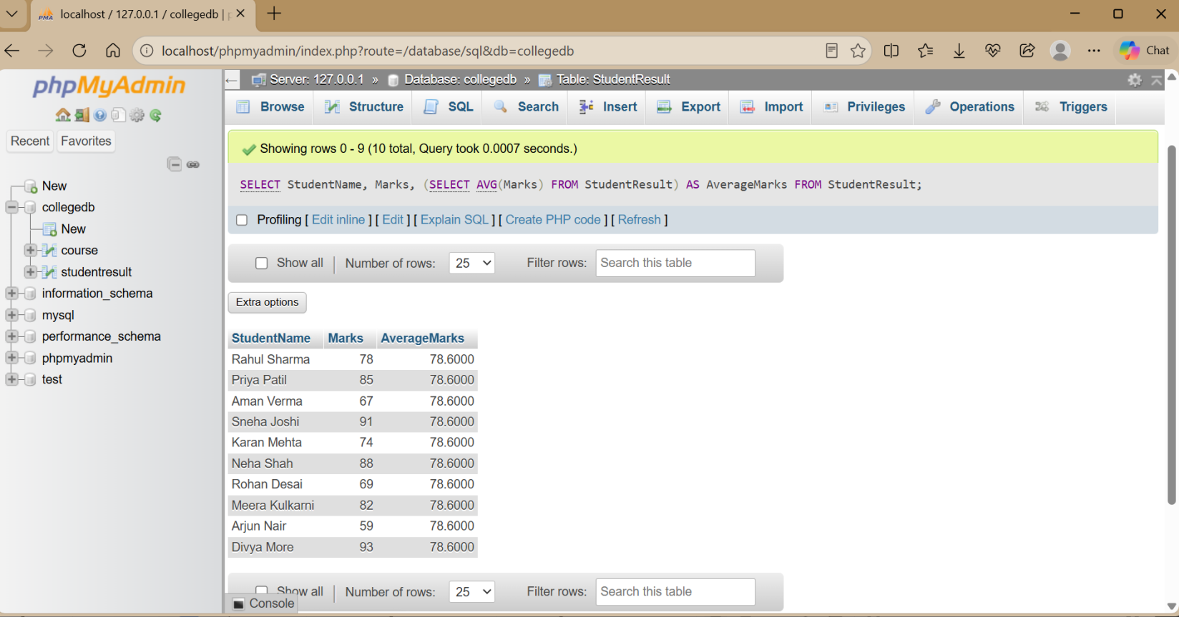

The subquery calculates one overall average and displays it alongside every student.

Q5) Display students who scored more than their own course average using a correlated subquery.

SELECT StudentID, StudentName, CourseID, Marks
FROM StudentResult S1
WHERE Marks > (
SELECT AVG(Marks)
FROM StudentResult S2
WHERE S2.CourseID = S1.CourseID
);

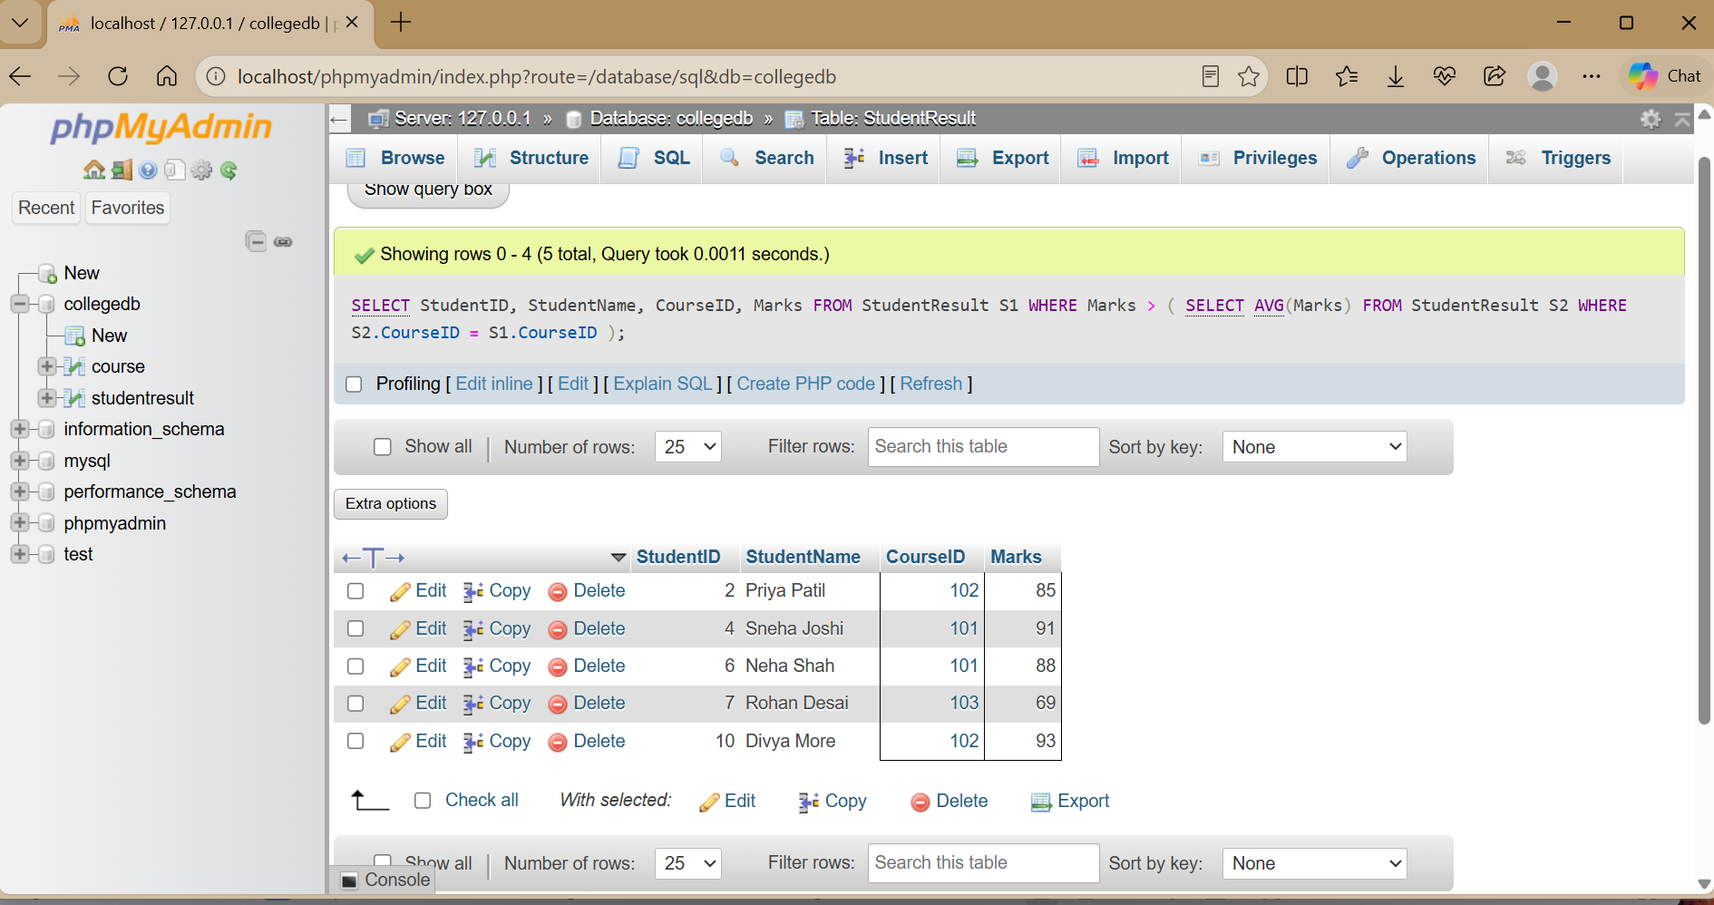

The inner query depends on the CourseID of the current outer-row student, so the average is calculated separately for each course.

Q6) Display courses having students and courses having no students using EXISTS and NOT EXISTS.

Using EXISTS

SELECT CourseID, CourseName FROM Course C
WHERE EXISTS ( SELECT 1
FROM StudentResult S
WHERE S.CourseID = C.CourseID
);

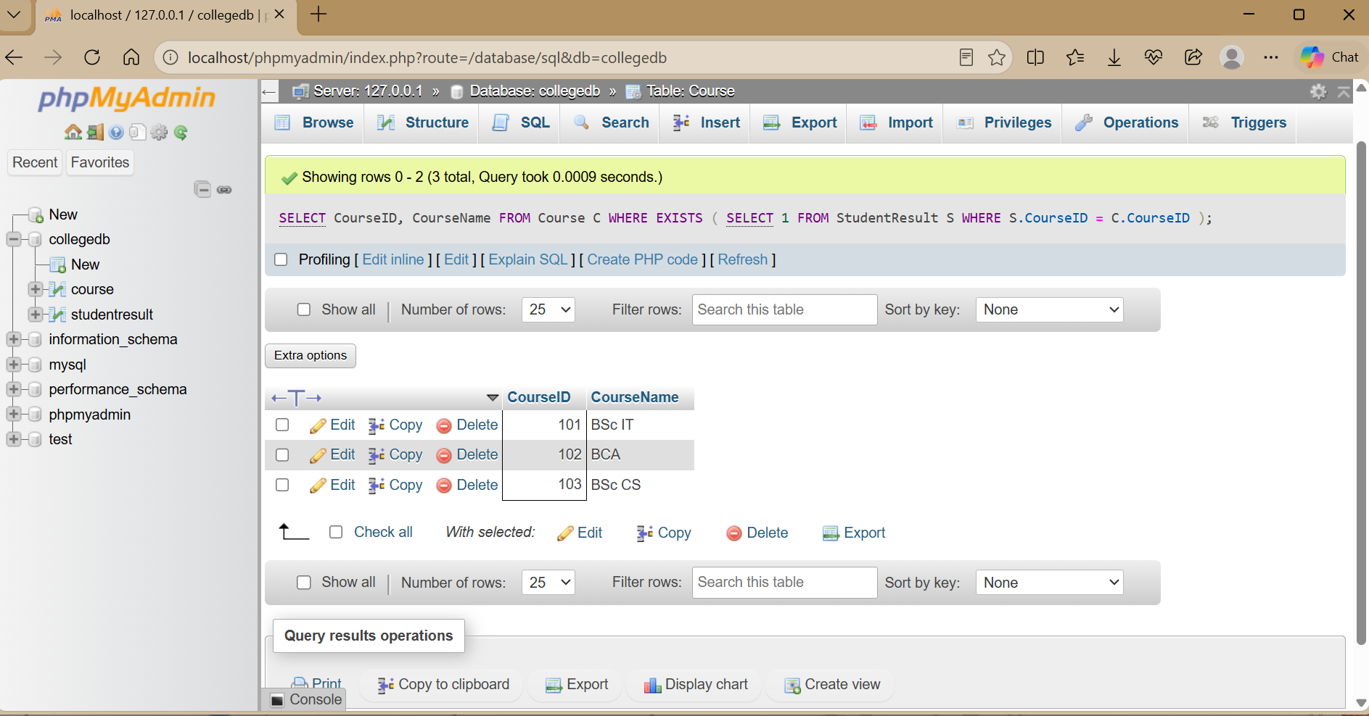

Using NOT EXISTS

SELECT CourseID, CourseName FROM Course C
WHERE NOT EXISTS ( SELECT 1
FROM StudentResult S
WHERE S.CourseID = C.CourseID
);

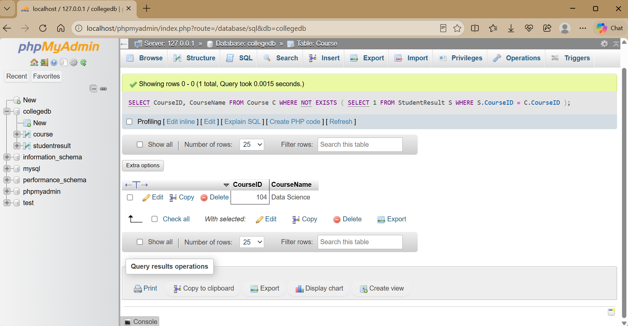

EXISTS checks whether at least one related student exists. NOT EXISTS checks whether no related student exists.

THANK YOU

